
input here

This is to certify that

{fullName}



Has successfully completed instruction in and has demonstrated the knowledge and competencies to receive the following

TEMPORARY CERTIFICATE

Master of Yachts Limited 200 Ton Power Practical Course & Examination

and is being issued this temporary certificate valid for 6 weeks from date of issue by XONE SUPERYACHT ACADEMY.
The candidate’s documents have been forwarded to International Yacht Training Worldwide for final certificate processing.
The final certificate will be issued by International Yacht Training Worldwide upon receipt of: proof of required seatime,
proof of STCW ’95 certification, proof of medical fitness by a legitimate medical organization/doctor including color blind testing, and proof
of a valid VHF radio operator’s certificate.

.
{certNo}
This course was completed with
Partner School Principal or Instructor Printed Name

Partner School Principal or Instructor Signature
{expiryDate}

Temporary Certificate Number

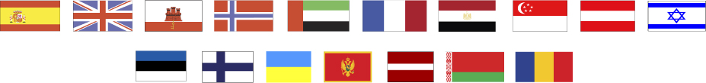
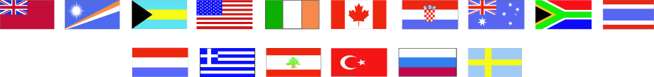
Date of Course Conclusion

XONE SUPERYACHT ACADEMY MALTA
EMIN CIHAN DUYAN
{issueDate}
9

{dob}
9

Date of Birth: _________________

Date of Issue: _________________
International Yacht Training Worldwide
Suite 482; 9-3151 Lakeshore Rd
Kelowna, B.C V1W 3S9; Canada
www.IYTworld.com

XONE SUPERYACHT ACADEMY
Skyway offices 179 Marina Street Block C/2 PTA 9042 Pieta Malta

